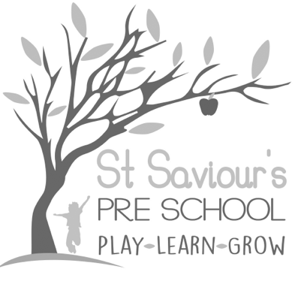
8.8 ENVIRONMENTAL SUSTAINABILITY POLICY

Written by: Claire Toms and Tina Alder Date: 28.8.25.

Policy statement
At St Saviour’s Pre-school and Nursery we support children to learn about sustainable practices and foster respect and care for both the living and non-living environment.
Children develop positive attitudes and values about sustainability by:
- exploring solutions to environmental issues,
- learning about the world around them and how to protect it, and
- watching adults role model responsible, sustainable behaviours.
Our curriculum embeds sustainability across all areas of learning, as outlined in the EYFS 2025 Understanding the World requirement, which encourages children to explore and respect the natural world and consider how their actions impact future generations.

Procedures

Learning and Development
We provide opportunities for children to:
- Explore nature through art, play and sensory activities.
- Experience the natural environment using natural materials such as wood, stone, sand, and recycled resources.
- Learn how to grow and nurture plants, while discovering the food cycle through growing, harvesting and tasting foods.
- Understand water conservation, energy efficiency and waste reduction through hands-on, play-based activities.
- Go on local nature walks, learning about plants, wildlife, and habitats in the community.
- Develop awareness of sustainable travel by encouraging walking, scooting or cycling to nursery.
- Learn about recycling and waste reduction, encouraging children to share and practise a recycling ethos at home.

Nursery Operations
We commit to embedding sustainability into the daily running of the setting by:
- Recycling materials for art and creative activities, encouraging parents to contribute safe recycled items.
- Supporting families to recycle children’s take-home models if they are no longer kept.
- Considering our carbon footprint when purchasing materials, and choosing local and sustainable suppliers where possible.
- Turning off equipment and lights when not in use, and ensuring equipment is not left on standby.
- Unplugging electrical items at the end of the day.
- Hanging washing out to dry or using airers where possible rather than tumble dryers.
- Composting food waste where safe and appropriate.
- Incorporating water-wise strategies, including fixing leaks promptly and ensuring taps are turned off after use.
- Recycling water from play activities to water plants and garden areas.

Safeguarding and Healthy Practices
- Children are taught not to waste food and to show respect for mealtimes.
- We avoid using food as a play material, instead promoting food-based activities that focus on preparation, cooking, and tasting different foods.
- Sustainability messages are shared with parents, so children experience consistent messages at home and nursery.

Review and Monitoring
- We regularly assess the nursery’s environmental impact and put new procedures in place to reduce this impact.
- Staff are encouraged to bring ideas for new sustainability practices.
- The policy is reviewed annually in line with the EYFS and Hertfordshire County Council guidance.
.

